Day 68: Scan Flip-Flop

Introduction: A Scan Flip-Flop is a modified D Flip-Flop used in digital integrated circuits for testing internal logic. It has an additional control input called Scan Enable (SE) and a Scan Input (SI). The Scan Enable signal selects between normal data input (D) and scan input (SI). When SE is LOW, the flip-flop captures normal data D. When SE is HIGH, it captures scan input SI at the active clock edge.

Design:

Testbench:

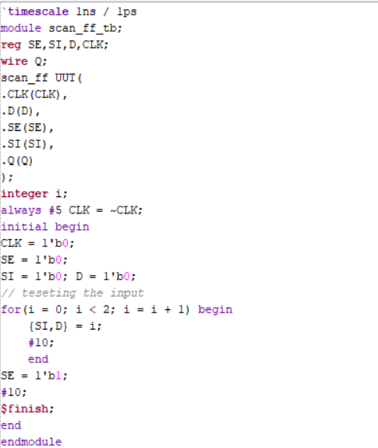

Waveform:

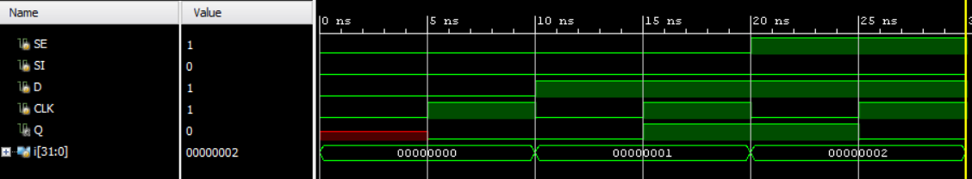

Schematic:

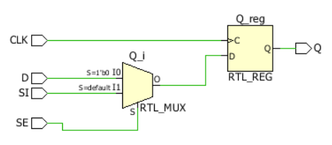

Working principle:
Scan Enable (SE) | Selected input | Operation
0 | D | Normal operation
1 | SI | Scan operation

Power Analysis and On-Chip Power Summary

Uses of Scan Flip-Flop
- Used in Design for Testability (DFT).
- Helps test internal registers in digital circuits.
- Used to shift test data into and out of a chip.
- Helps detect manufacturing defects in integrated circuits.
- Used in testing complex digital systems such as processors and controllers.

Applications
1. VLSI Testing: Scan Flip-Flops are used to test internal logic and registers in VLSI chips.
2. Microprocessors: Used to test internal registers and logic circuits in processors.
3. System-on-Chip (SoC): Used in testing different internal blocks of complex integrated circuits.
4. Digital Integrated Circuits: Used to improve testability and identify manufacturing faults.
5. Embedded Systems: Used during chip development and manufacturing testing of digital controllers and embedded processors.

Observation: The Scan D Flip-Flop was designed and verified using Verilog HDL in Xilinx Vivado. The simulation results demonstrate that when Scan Enable is LOW, the flip-flop captures normal data D. When Scan Enable is HIGH, it captures scan input SI at the active clock edge. This demonstrates how scan flip-flops support testing of internal digital circuits.

#PHANEENDRA.SINGUDASU

